SentinelOne Troubleshooting Steps:

* SentinelOne Service status – via Command line as well as Services.msc (make sure all set to automatic)
* Make sure enough disk space minimum 2 GB – if not, request the team to clean the diskspace and reboot the machine and validate the S1 services.
* Try to unload and load the S1 services.
* If started, move on to the next machines.
* If not started, please perform the below the checks,
  + Telnet to S1 management console [Sentinelone Console URL] and Port - 443] using PortQryUI tool.
  + If it’s filtered – please ask them to check the Network connection.
  + If it’s listening – Move to next check.
  + Check the TLS is enabled on the Registry location - HKEY_LOCAL_MACHINE\SYSTEM\CurrentControlSet\Control\SecurityProviders\SCHANNEL\Protocols\
  + If you don’t find the TLS folder there, then it’s enabled by default.
  + Check the Event Viewer any service timeout error with S1. Event Viewer→Windows Logs→System

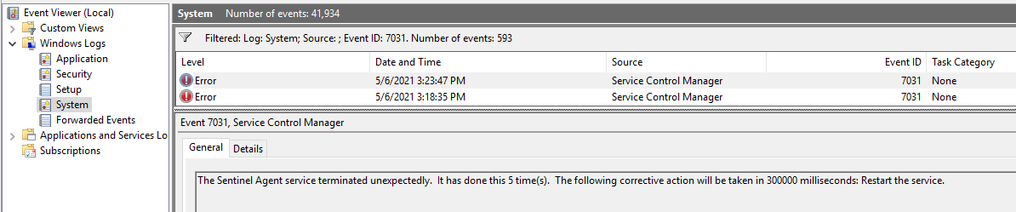

* Try to reboot the machine